PROJECT – IITG COVID HELP



YOU MAY NOT CONTROL ALL THE EVENTS THAT HAPPEN TO YOU, BUT YOU CAN DECIDE NOT TO BE REDUCED BY THEM.

THIS PROJECT IS BROUGHT TO YOU ALL BY:

1. Devika Singh 210101036
2. Tripti Rani Kachhap 210101106
3. Ridhiman Kaur Dhindsa 210101088
4. Sreehari C 210101101

NO NEED TO PANIC ANYMORE!!!

**IITG COVID HELP IS HERE FOR YOU ALL!**



**Problem Statement**

How to manage to contain COVID-19 in an academic residential campus in the event of outbreak?

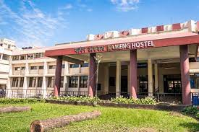

**Scenario**

**Due to sudden COVID-19 outbreak in the entire North-East, the campus of IIT Guwahati has become a containment zone. It’s getting difficult for the students as well as the faculties to reside there. But also, at the same time, ministry of railways has closed the transportation and so no one can return home back.**

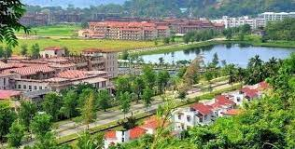

Solution

**So, What our team has done to deal with such a situation and provide optimum solution for it and to help the people across the campus.**



1. Our team has developed a ***website*** which contains the database of everyone residing in the campus.
2. The team has collected the contacts of all the medical professionals, doctors and nurses and has made a database of the contact number for the ease of patients.
3. The team has built a Covid Response Team (CRT) which will be available 24 hours to contact and help the patients with their requirements.



1. The CRT is divided into 5 with parts:
2. **Beds -** They will keep the data of vacant beds and isolation rooms every day. As soon as anyone needs it, they will provide them with it.
3. **Medicines –** They will provide the patients with data of availability of first aid medicines required in Covid and the medico shop from where they can get it asap.
4. **Oxygen cylinder and its components –** This team will keep the data of oxygen cylinder availability and the cylinder components. If a patient has mild symptoms. They will be provided within no time.
5. **Blood Plasma –** This team will keep the everyday data from all the hospitals about the availability of blood plasma. If a patient gets severe or is in urgent need of blood plasma, they will be sent to the respective hospitals.
6. **Groceries and Food –** This team will take care of groceries and food availability and will make sure that every patient gets 3 meals per day.

The CRT teams will have one head for each division, as soon as a someone is found positive for Covid, the head will get a call, and the she/he will refer to its team mates about it, and then tell the patient about the proper availability of their requirement.

**The Working of the website: **

Everyone residing in the campus will be registered in the website with their IITG email ID and location will also be traced and a map will be given. 

RT-PCR testing will be done everyday at the public places especially the messes, hostel entries, library and offices.

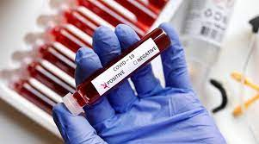

If one is found positive anytime, his/her will be highlighted in red

Immediately in the database of our website and the team will get a notification. The further process will be taken care of by the CRT team about the availability of isolation bed.

The CRT will check for the doctor available at that time and then a team of doctors and nurses will be sent.

The location of the patient will be traced for the last 5-6 days, and those areas will be red marked in the map given the website.

Everyone will be getting the notification as soon as one tests positive for Covid. And they will receive a mail about the areas most red marked each day.

The website data will also contain the data of all the doctors and nurses available which will be updated in every 12 hours.



A *team of counsellors* will be available 24 hours to whom anyone can reach and chat via our website. Just go to the CHAT tab, and you will also be provided with a option to chat anonymously if you want to.



BUT WHAT’S NEXT??

The website will ask for volunteers who will be registered in website and they will do Vaccination Awareness campaigns in the entire campus.

Then, as per the data provided by the volunteers, the website will start updating the new list of vaccinated members.

Each day doctors and nurses will go and vaccinate atleast 20 people residing in the campus. And after their vaccination, it’s the duty of volunteers to provide them with potential and required medicines to counter the post vaccination symptoms.

Every member vaccinated will be marked green in the database now.

